***STUDY DESIGN***

This is a retrospective study that analyzes the quality indicators of the endoscopy unit of a Vila Nova Star Quaternary Hospital – Rede Do´r (São Paulo, Brazil) since its inauguration (May 27, 2019 to April 30, 2023).

This study protocol and manuscript preparation were carried out in accordance with the Strengthening the Reporting of Observational Studies in Epidemiology (STROBE) guidelines. Institutional Review Board approval for retrospective analyzes was obtained for each center prior to data collection.

***DATA COLLECTION PROCESS***

Patient data, including gender, age and attendance number, were collected from an electronic spreadsheet (Excel) that documented the colonoscopy exams performed at Hospital Vila Nova Star – Rede Do´r, São Paulo, Brazil. Using the Hospital's data system (TASY), patient contact numbers and ultrasound results were obtained, taking each patient's service number as a reference.

Subsequently, an evaluative survey was carried out through telephone calls. The objective of this telephone approach was to acquire additional information about the patients' pre- and postoperative periods, and also to collect a subjective assessment from patients regarding their experience with the hospital's endoscopic medical service. This included the patient's motivation to undergo the endoscopic examination, as well as assessing the late postoperative status, especially if they experienced difficulties in ingesting fat after the gallbladder removal, or if they manifested symptoms such as nausea or other discomforts. During this collection process, we faced challenges: not all patients were still alive, others refused to participate.

**METHODS**

***STATISTICAL ANALYSIS***

The variables were distinctly classified as qualitative or quantitative and analyzed according to their nature. Qualitative variables were analyzed using absolute and relative frequencies, providing a clear view of the predominant categories. Quantitative variables, in turn, were expressed as mean and standard deviation.

To compare groups with numerical variables, the t test was used, while the chi-square test was applied to categorical variables. Statistical significance was previously established, considering a p value of less than 0.05 as the threshold for relevance. Additionally, a logistic regression model was used to estimate the odds ratio, quantifying the effect size of the association between two categorical variables.

All analyzes were performed using the statistical software R, version 4.3.1 (R Foundation for Statistical Computing).

***RESULTS***

The study sample comprised 919 patients, with a mean age of 50 years and a standard deviation of 13.24 years. Of the total, 52.1% (n=479) were female and 47.9% (n=440) male.

**Figure #. Total number of exams performed.**

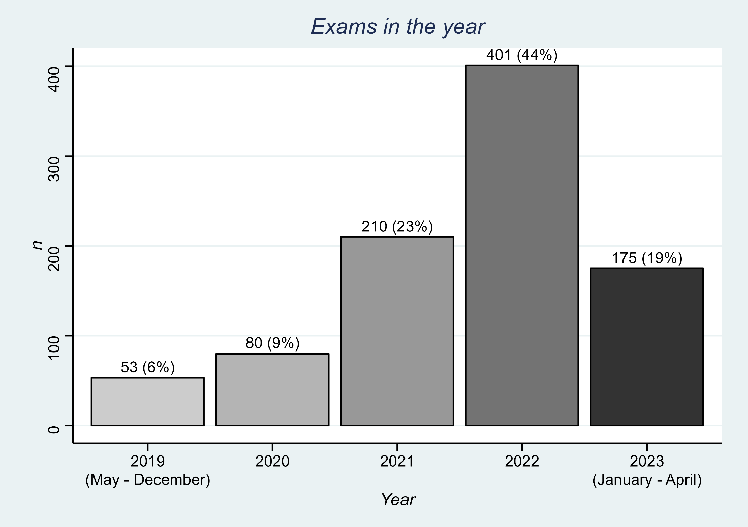

Of the patients evaluated, 25.02% (n=230) did not undergo the examination to evaluate the pancreatic tract. Among the indications for these procedures, 44.8% (n=103) had already undergone cholecystectomy, 47.4% (n=109) revealed subpiterrial lesions during the examination, 4.3% (n=10) showed gastric stasis during the evaluation and 3.5% (n=8) underwent examination using a miniprobe.

Among the patients who underwent pancreatic evaluation, 79.4% (n=547) showed microstones in the gallbladder.

**Table#. Annual Detection Rate of Microcalculi, demonstrations with counts (n), percentages.**

|  |  |  |  |
| --- | --- | --- | --- |
|  | **Microcalculations Found** | |  |
| **Exam Year** | **No** | **Yes** | **P-value** |
|  |  |  | < 0.001 |
| **2019** | 40.00% (18) | 60.00% (27) |  |
| **2020** | 28.33% (17) | 71.67% (43) |  |
| **2021** | 22.09% (36) | 77.91% (127) |  |
| **2022** | 19.11% (56) | 80.89% (237) |  |
| **2023** | 11.72% (15) | 88.28% (113) |  |
| **Overal** | **20.61% (142)** | **79.39% (547)** |  |

**Figure#. Annual Detection Rate of Microcalculi, demonstrations with counts (n), percentages.**

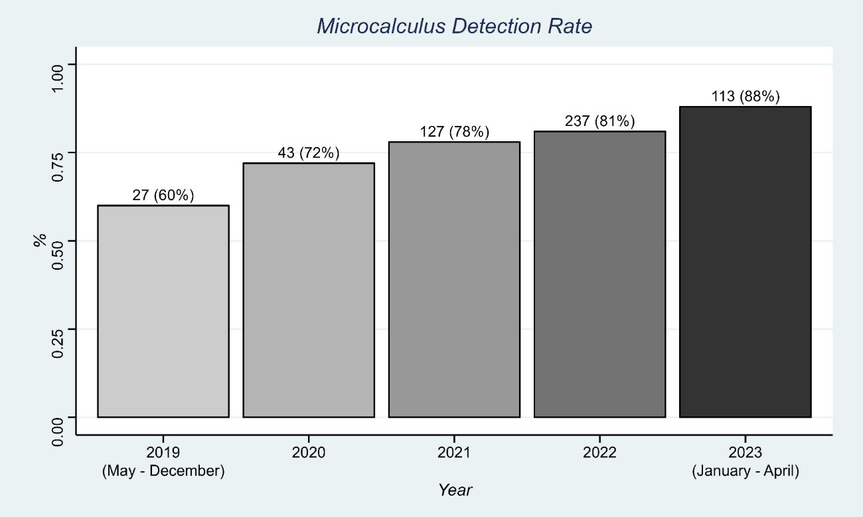

A significant association was identified between the microcalculus detection rate and the year of examination (P < 0.001, chi-square test). The analysis revealed a linear increasing trend in the detection rate of microstones over the years. This observation was subsequently validated using a linear regression analysis, which confirmed the statistical significance of this upward trend (P < 0.001).

**Table#. Comparison of Age (Mean ± Standard Deviation) Between Patients With and Without Microcalculus.**

|  |  |  |  |  |
| --- | --- | --- | --- | --- |
| **Variable** | **Overall** | **No** | **Yes** | **P-Value** |
| **Age** | 49.00 ± 13.93 | 53.00 ± 10.60 | 54.00 ± 14.60 | 0.70 |
| **Gender** |  |  |  | 0.45 |
| Female | 46.88% (323) | 50.00% (71) | 46.07% (252) |  |
| Male | 53.12 (366) | 50.00% (71) | 53.93% (295) |  |

Patients in whom microstones were detected had a mean age of 53 years, with a standard deviation of 10.60 years. In contrast, those who did not have microcalculations recorded a mean age of 49 years, with a standard deviation of 13.93 years. The difference between these groups was not statistically significant, respectively, as confirmed by the hypothesis tests, t-test (P = 0.70) and Chi-Square (P = 0.45).

**Table#. Microcalculus detection rates stratified by sex, demonstrations with counts (n), percentages.**

|  |  |  |  |
| --- | --- | --- | --- |
| **Microcalculos** | **Overall** | **Female** | **Male** |
| **No** | 20.61% (142) | 21.98% (71) | 19.40% (71) |
| **Yes** | 79.39% (547) | 78.02% (252) | 80.60% (295) |

The detection rate of microstones in female patients was 78.02% (n=252), while in male patients it was 80.60% (n=295).

**Evaluative Research**

Among the patients in whom vesicular microcalculi were identified, a total of 349 participated in the subsequent evaluative research. Of the respondents, 58.3% (n=203) elected to undergo surgical intervention, while a proportion of 41.7% (n=145) chose not to undergo the surgical procedure. Additionally, it was observed that 52.9% (n=184) of patients underwent the exam due to the manifestation of clinical symptoms, while 47.1% (n=164) underwent the exam as part of a routine check-up. . With a statistically significant difference (p < 0.001; Chisq-Squared) and Odds Ration 3.68 (2.36 – 5.81, P < 0.001).

Table #: Distribution of Patients According to Surgical Decision and Motivation for the Exam.

|  |  |  |  |  |
| --- | --- | --- | --- | --- |
|  | Geral | No Operated | Operated | P-value |
| Checkup | 47.13% (164) | 65.52% (95) | 33.99% (69) | < 0.001 |
| Symptoms | 52.87% (184) | 34.48% (50) | 66.01% (134) |  |

Odds: 3,68 (2,36 – 5,81, P < 0,001)

**Figure #: Distribution of Patients According to Surgical Decision and Motivation for the Exam.**

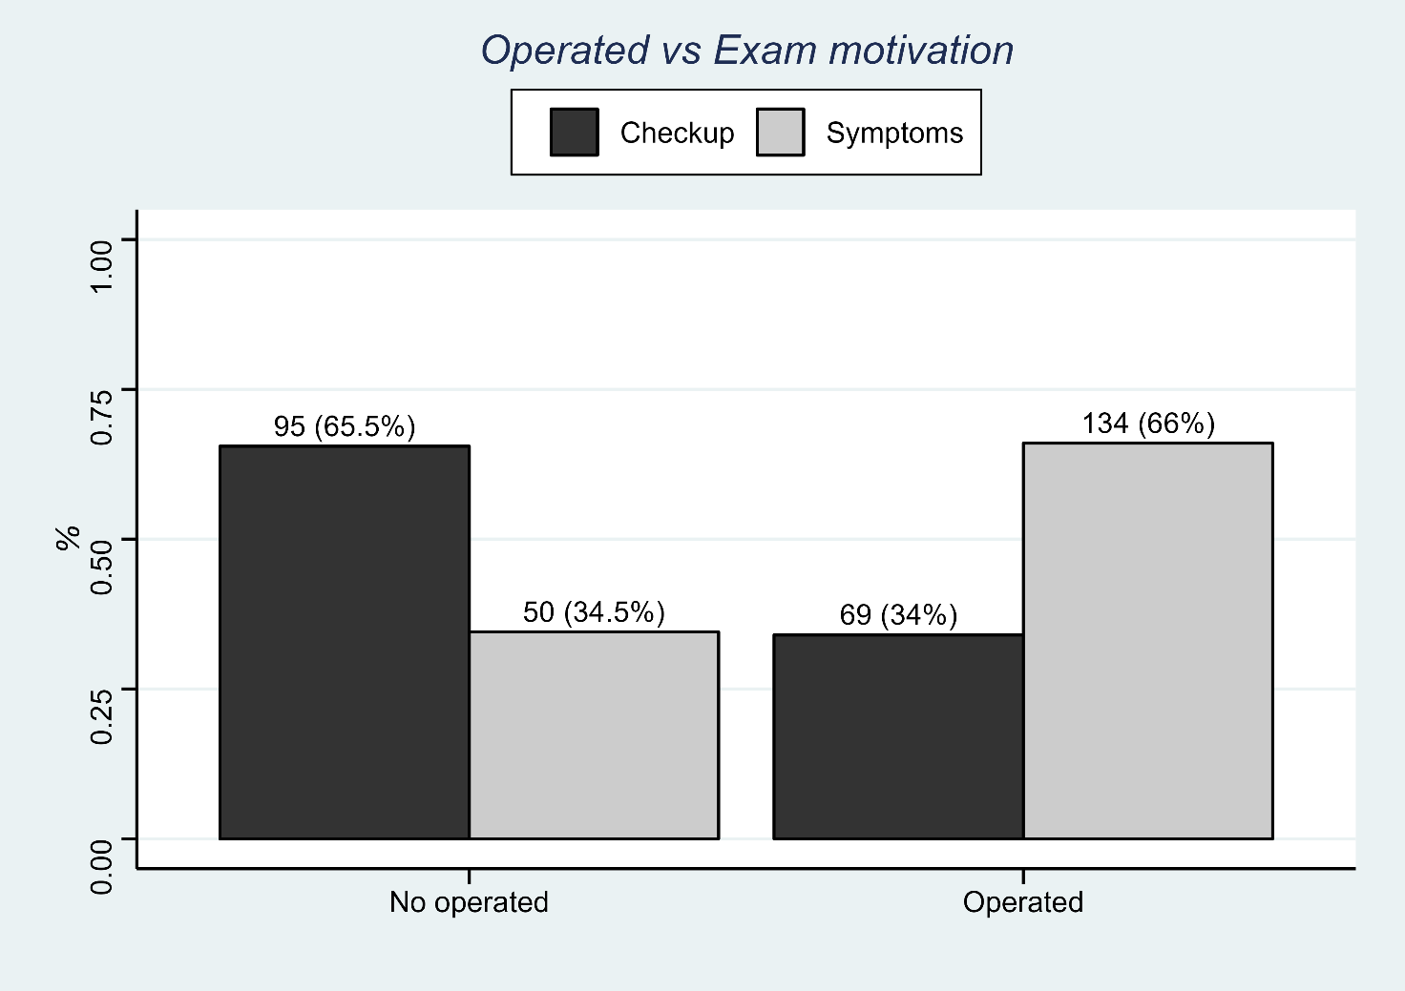

Among the patients who reported symptoms, 72.2% (n=143) reported experiencing pain in the right hypochondrium, followed by 44.7% (n=89) reporting reflux. Nausea and vomiting were reported by 26.7% (n=51), gastric symptoms by 13.2% (n=25), fatigue by 3.2% (n=6), diarrhea by 2.7% (n= 5), fever in 1.1% (n=2) and other symptoms in 2.2% (n=4) of patients.

**Figure #: Distribution of Symptoms Motivating The Exam.**

**OBS: ESSAS TAXAS NÃO SÃO COMPLEMENTARES, SÃO VARIAVEIS DISTINSTAS DOS SINTOMAS QUE MOTIVARAM O PACIENTE A FAZER A ECO, POR ISSO O SOMATORIO NÃO É 100%**

**SE ACHAR UMA ANÁLISE COMPLEMENTAR DOS SINTOMAS, QUE SERIA “PRINCIPAL MOTIVAÇÃO PARA FAZER O EXAME”, SÓ FALA COMIGO QUE EU FAÇO.**

Among patients who opted for surgery due to symptoms (72.80%, n=134), a significant portion of 73.9% (n=99) reported complete resolution of postoperative symptoms, additionally, 22.4% (n=30) experienced a partial improvement, while a minority of 3.7% (n=5) observed no change in their symptoms after the surgical procedure. Among patients who chose not to undergo surgery (27.20%, n=50), only 20.00% (n=10) reported complete resolution of symptoms. Additionally, 44.00% (n=22) experienced a partial improvement, while a considerable proportion of 36.00% (n=18) did not observe any improvement in their symptoms. These distributions showed statistically significant differences, as evidenced by the Chi-square test (P < 0.001).

**Figure #: Distribution of Current vs Operated Status Distribution**

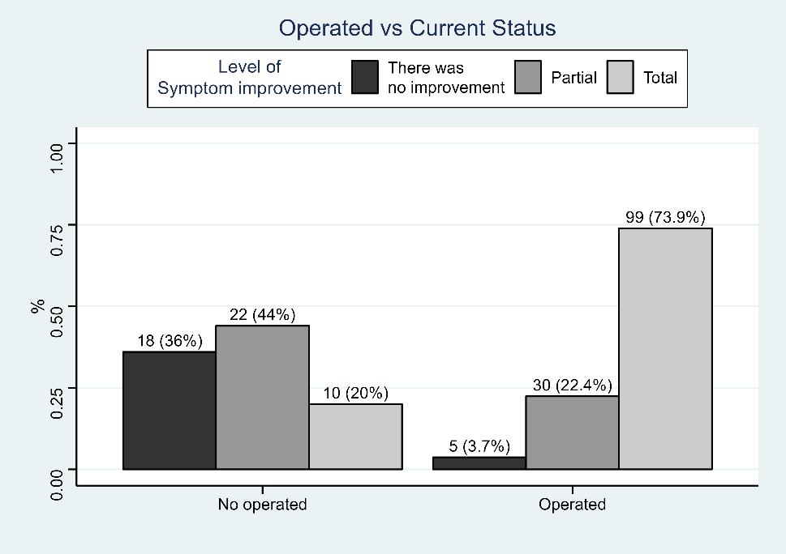

**Fiz o mesmo calculo depois com esses dados em binário para possibilitar o calculo do tamanho do efeito (odds ratio), segue abaixo.**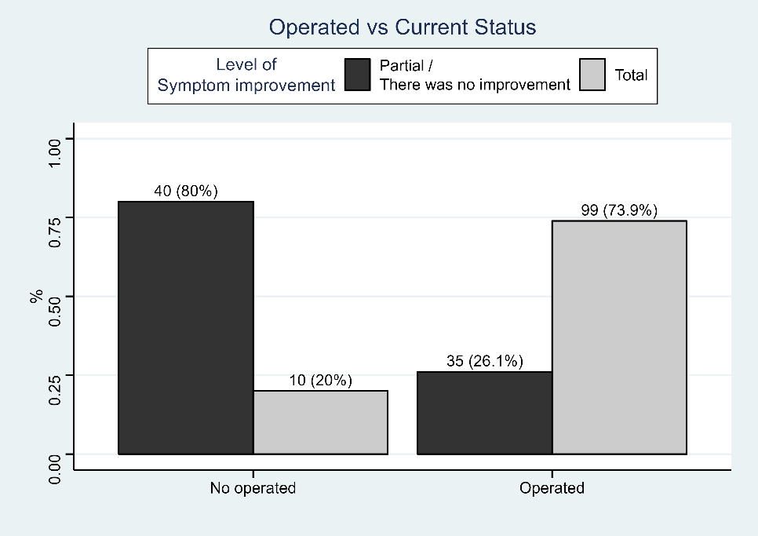

When binarizing these rates, with the aim of evaluating the impact on the outcome of complete resolution of symptoms, a significant effect (P < 0.001) was observed, once again, using the Chi-square test. The Odds Ratio was 11.31 (95% Confidence Interval: 5.29 to 26.18), demonstrating a significant tendency towards complete improvement of symptoms when the patient undergoes surgery.

Of the total number of patients who underwent surgery, 54.8% (n=110) faced complications or limitations in the late postoperative period, including difficulties in eating fatty foods.

Regarding the evaluation of the experience with medical care during the hospital stay, a large majority, 81.6% (n=284), evaluated it as “Excellent”. Another 14.9% (n=52) considered the service to be “Good”, while 1.4% (n=5) had a “Neutral” perception and 2.0% (n=7) classified it as “Unsatisfactory” . It is important to highlight that the experiences reported as unsatisfactory were not directly associated with the medical care itself, but rather with administrative issues, such as delays in care, problems during hospitalization, undue charges and inadequate hospital management.

